.


Compensation and Pension Record Interchange (CAPRI)

CAPRI-Templates - Standard Objects, Phase I (DVBA*2.7*142) Release Notes

October 2009

Department of Veterans Affairs
Office of Enterprise Development
Management & Financial Systems

Preface
Purpose of the Release Notes
The Release Notes document describes the new features and functionality of CAPRI Templates - Standard Objects, Phase I (DVBA*2.7*142) patch.

Reference Numbering System
This document uses a numbering system to organize its topics into sections and show the reader how these topics relate to each other. For example, section 1.3 means this is the main topic for the third section of Chapter 1. If there were two subsections to this topic, they would be numbered 1.3.1 and 1.3.2. A section numbered 2.3.5.4.7 would be the seventh subsection of the fourth subsection of the fifth subsection of the third topic of Chapter 2. This numbering system tool allows the reader to more easily follow the logic of sections that contain several subsections.

Table of Contents
1. Overview 2
2. Associated Remedy Tickets and New Service Requests 3
3. Defect Fixes 4
3.1 Defect fixes without Remedy tickets 4
3.1.1. Medical Opinion Template Corrections 4
3.1.2. Vital Signs Weight Percentage 5
4. Enhancements 6
4.1 Standard Object Enhancements 6
4.1.1. Standardized Panels 6
4.1.2. Acromegaly Template 15
4.1.3. Arrhythmias Template 16
4.1.4. Diabetes Mellitus Template 17
4.1.5. General Medical Examination Template 17
4.1.6. Gulf War Guidelines Template 18
4.1.7. Heart Template 18
4.1.8. Hemic Diseases Template 19
4.1.9. Hypertension Template 20
4.1.10. Prisoner of War Protocol Examination Template 21
4.1.11. Pulmonary Tuberculosis and Mycobacterial Diseases Template 21
4.1.12. Respiratory (Obstructive, Restrictive, and Interstitial) Template 22
4.1.13. Respiratory Diseases, Miscellaneous Template 23
4.1.14. Thyroid and Parathyroid Diseases Template 23
4.2 Template Enhancements 24
4.2.1. Weight Change: Loss with no % of weight change selected 24
4.2.2. Weight Change: Gain with no % of weight change selected 25
4.2.3. Weight Change: None with no % of weight change selected 26
5. Software and Documentation Retrieval 28
5.1 VistA Patch DVBA*2.7*142 28
5.2 User Documentation 28

Table of Figures
Figure 3.1.1.1: Legally Recognized Phrase 4
Figure 3.1.1.2: Standard Examiners Medical Opinion 4
Figure 4.1.1.1a: History Tab 6
Figure 4.1.1.1b: Trauma 7
Figure 4.1.1.1c: Neoplasm 7
Figure 4.1.1.1d: Cardiac History (Brief) 8
Figure 4.1.1.1e: Cardiac History (Comprehensive) 8
Figure 4.1.1.1f: Pulmonary History (Brief) 9
Figure 4.1.1.1g: Pulmonary History (Comprehensive) 10
Figure 4.1.1.2a: Physical Exam Tab 11
Figure 4.1.1.2b: Residuals of Neoplasm 11
Figure 4.1.1.2c: Cardiac Examination 12
Figure 4.1.1.2d: Pulmonary Exam 12
Figure 4.1.1.3a: Tests Tab – Stress Test 13
Figure 4.1.1.3b: Tests Tab – LV Dysfunction 13
Figure 4.1.1.3c: Tests Tab – Heart Size 13
Figure 4.1.1.4a: Diagnosis Tab 14
Figure 4.1.1.4b: Employment History 14
Figure 4.1.1.4c: Diagnosis 15
Figure 4.2.1a: Weight Change: Loss – Entered on Template 24
Figure 4.2.1b: Weight Change: Loss – Displayed on Report 25
Figure 4.2.2a: Weight Change: Gain – Entered on Template 26
Figure 4.2.2b: Weight Change: Gain – Displayed on Report 26
Figure 4.2.3a: Weight Change: None – Entered on Template 26
Figure 4.2.3b: Weight Change: None – Displayed on Report 27

Overview
In the Compensation and Pension Record Interchange (CAPRI), there was a need to standardize the exam questions being asked across Compensation and Pension Worksheet Module (CPWM) templates as they relate to certain body systems. In order to accomplish this goal, the CAPRI development team has developed Standardized Panels that contain standardized components known collectively as Standard Objects (SO).
A major benefit of Standardized Panels and Standard Objects is to eliminate duplicate data entry on the CAPRI CPWM templates. The benefits of Standard Objects are seen when two or more CAPRI CPWM templates that present the same question(s) are merged. For example, once data has been entered on one of the merged templates, it appears on all of the other merged templates that share its Standard Objects. In addition, report coding has been revised for the Standard Objects so that the report format for each Standardized Panel or other Standard Object is consistent across the templates.

These new Standard Objects will be incorporated into the set of CPWM templates in three phases. The main purpose of the CAPRI Templates - Standard Objects, Phase I (DVBA*2.7*142) patch is to incorporate the first phase of the Standard Objects into the set of CPWM templates.
In addition, two defects have been corrected in the Medical Opinion template.
The information contained in this document is not intended to replace the CAPRI User Manual. The software defects and enhancements are briefly discussed so that readers are aware of high-level functional changes. The CAPRI User Manual should be used to obtain detailed information regarding specific functionality.

Associated Remedy Tickets and New Service Requests

There are no Remedy tickets or New Service Requests associated with this patch.

Defect Fixes

Defect fixes without Remedy tickets

Medical Opinion Template Corrections
Two defects have been corrected in the Medical Opinion template:

Legally Recognized Phrase

The legally recognized phrase 'Was less likely as not (50/50 probability) permanently aggravated by' will be changed to 'Was less likely as not (less than 50/50 probability) permanently aggravated by'. The legally recognized phrases are selectable when entering a standard medical opinion.

Figure 3.1.1.1: Legally Recognized Phrase
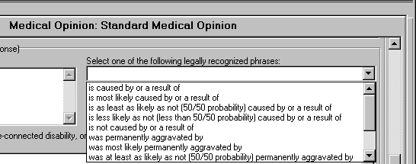

Standard Examiners Medical Opinion

'NONSTANDARD EXAMINERS MEDICAL OPINION' will be displayed as 'STANDARD EXAMINERS MEDICAL OPINION' on the report when a standard medical opinion is selected.
Figure 3.1.1.2: Standard Examiners Medical Opinion
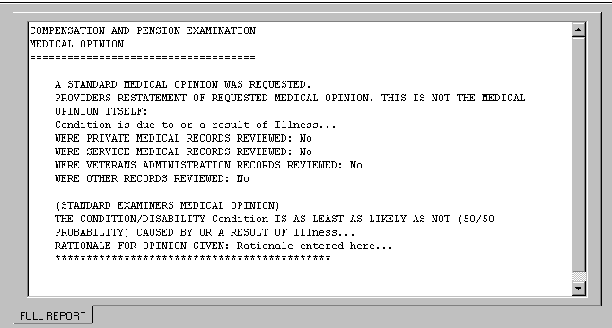

Vital Signs Weight Percentage
The values for the weight gain or loss percentage entered with Vital Signs on the Physical Exam tab did not display the percent sign (%) with the possible values. The values are now displayed as <10%, 10%, 20%, 30% and 40% or more. This change was implemented in all thirteen templates in the CAPRI Templates - Standard Objects, Phase I (DVBA*2.7*142) release: Hypertension, Respiratory, Heart, Diabetes Mellitus, Arrhythmias, General Medical Exam, Thyroid, Respiratory Diseases (Misc.), Pulmonary Tuberculosis Mycobacterial, Hemic, Acromegaly, Gulf War, and POW.

Enhancements
The following section is an overview of the enhancements that have been added in the CAPRI Templates - Standard Objects, Phase I (DVBA*2.7*142) patch release.

Standard Object Enhancements

Standardized Panels
The Veterans Benefits Administration Veterans Affairs Central Office (VBAVACO) approved the content for the Standardized Panels. These Standardized Panels were applied to the CAPRI CPWM template History tab, Physical Exam tab, Tests tab, and Diagnosis tab for thirteen templates in SO Phase I.

Standardized History Tab
Figure 4.1.1.1a: History Tab
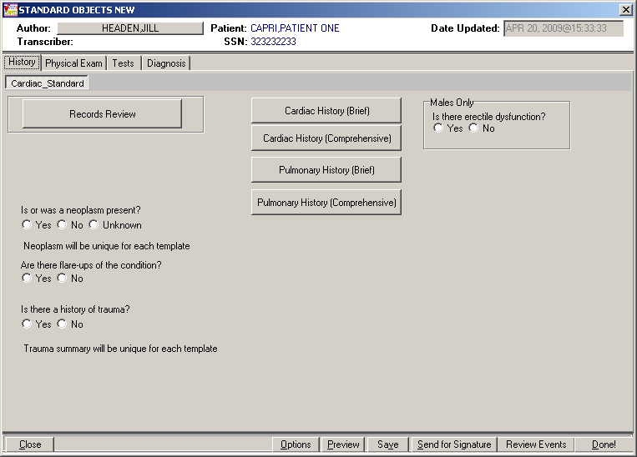
Figure 4.1.1.1b: Trauma
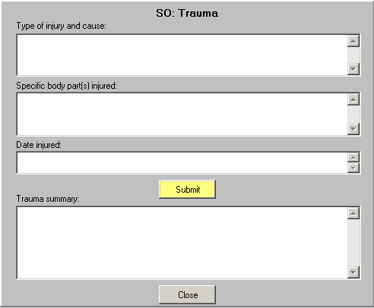
Figure 4.1.1.1c: Neoplasm
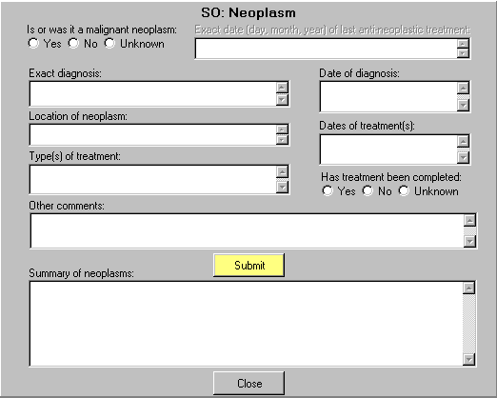
Figure 4.1.1.1d: Cardiac History (Brief)
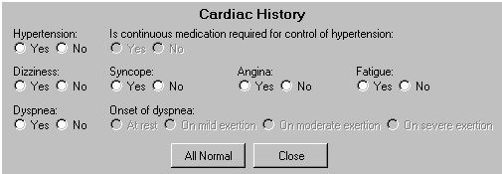
Figure 4.1.1.1e: Cardiac History (Comprehensive)
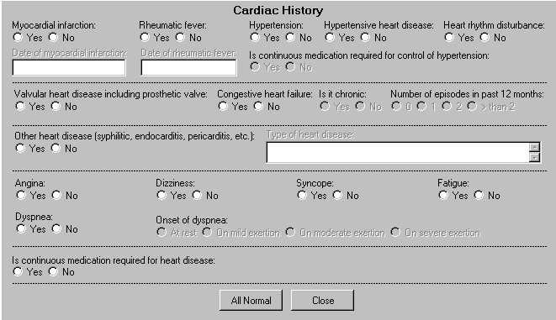
Figure 4.1.1.1f: Pulmonary History (Brief)
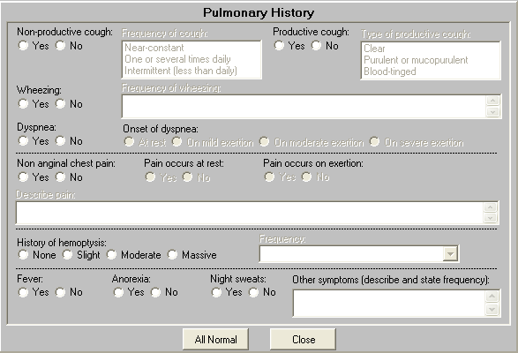
Figure 4.1.1.1g: Pulmonary History (Comprehensive)
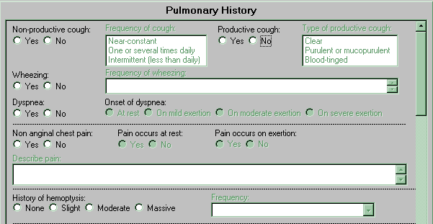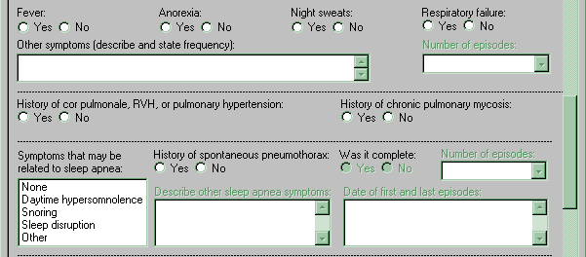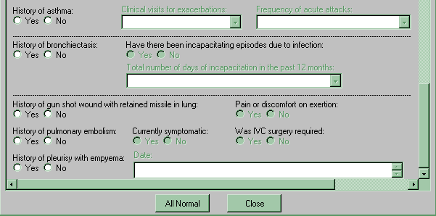

Standardized Physical Exam Tab
Figure 4.1.1.2a: Physical Exam Tab
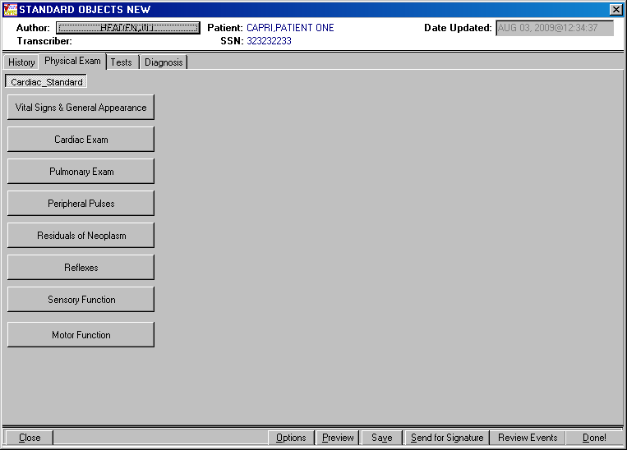
Figure 4.1.1.2b: Residuals of Neoplasm
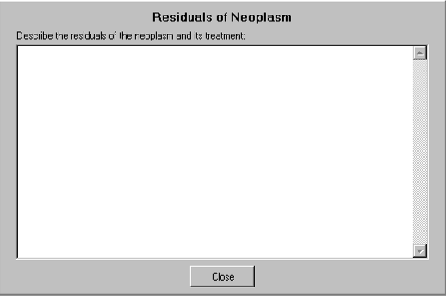
Figure 4.1.1.2c: Cardiac Examination
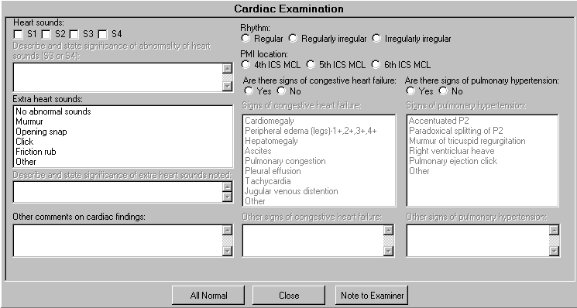
Figure 4.1.1.2d: Pulmonary Exam
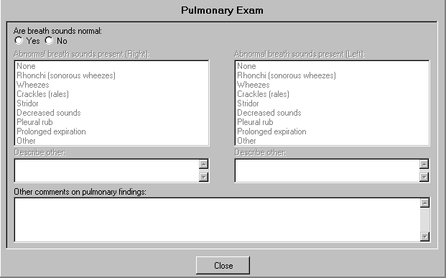

Standardized Tests Tab
The Tests tab contains Standard Objects for Stress Test, LV Dysfunction, and Heart Size that may be displayed together on a template or independently.

Figure 4.1.1.3a: Tests Tab – Stress Test
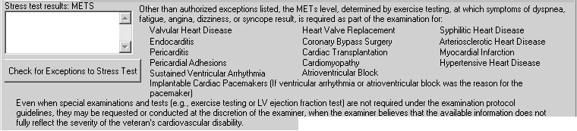
Figure 4.1.1.3b: Tests Tab – Exceptions to ETT Requirement
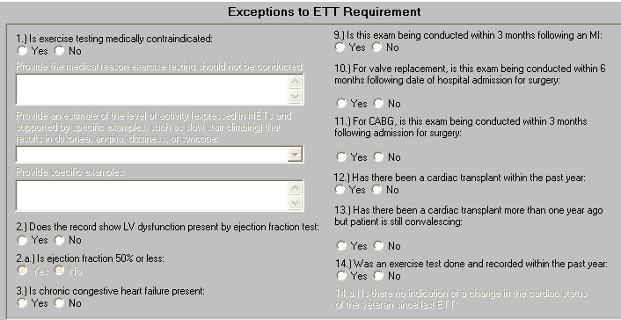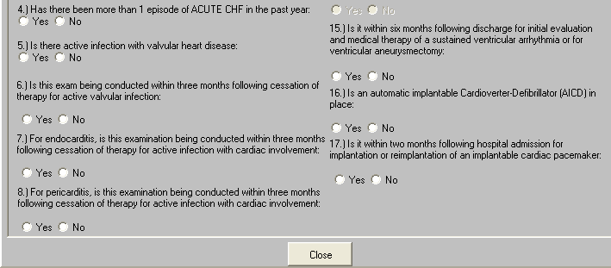

Figure 4.1.1.3c: Tests Tab – LV Dysfunction
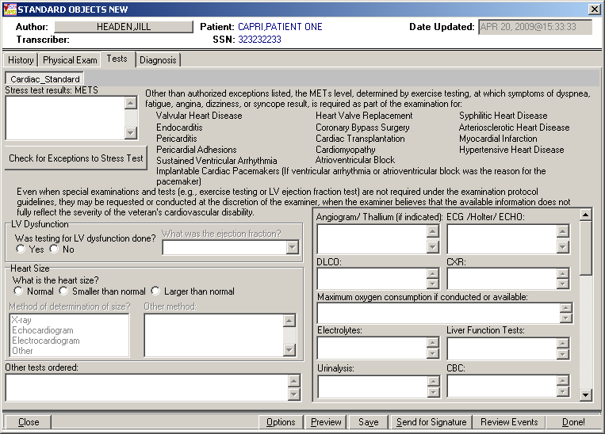
Figure 4.1.1.3d: Tests Tab – Heart Size

Standardized Diagnosis Tab
Figure 4.1.1.4a: Diagnosis Tab
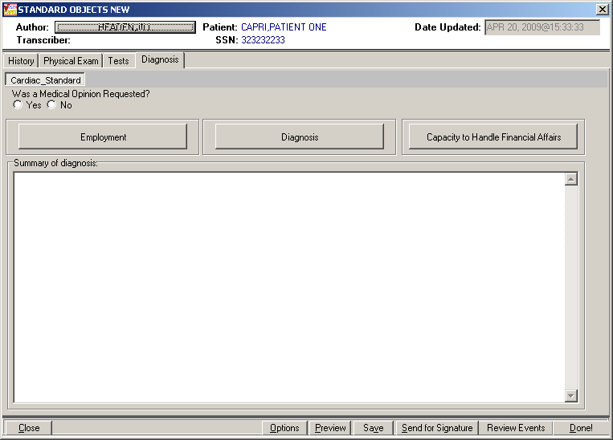
Figure 4.1.1.4b: Employment History
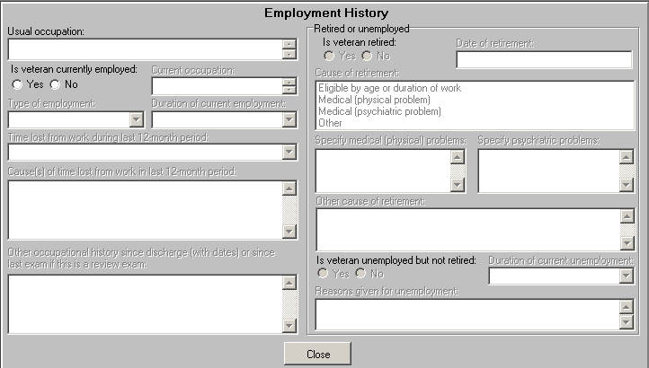
Figure 4.1.1.4c: Diagnosis
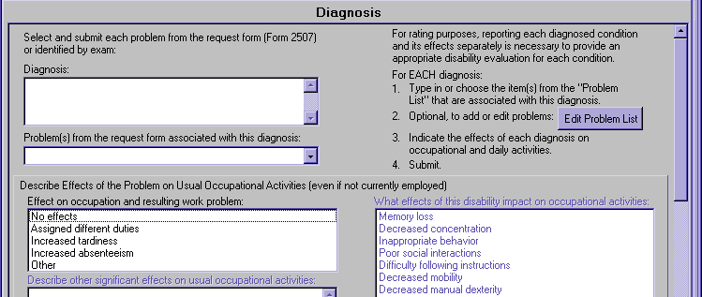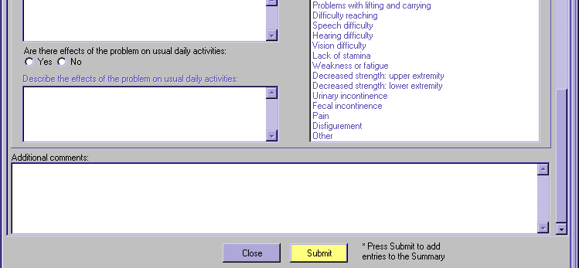

Acromegaly Template
The following Standard Objects were added to the Acromegaly template:

History Tab
Standardized Panels for the History tab include:
- Neoplasm
- Cardiac History (Brief)

Physical Exam Tab
Standardized Panels for the Physical Exam tab include:
- Residuals of Neoplasm
- Cardiac Examination
- Pulmonary Exam

Tests Tab
Standardized Panels for the Tests tab include:
- Heart Size

Diagnosis Tab
Standardized Panels for the Diagnosis tab include:
- Employment History
- Diagnosis

Arrhythmias Template
The following Standard Objects were added to the Arrhythmias template:

History Tab
Standardized Panels for the History tab include:
- Trauma
- Neoplasm
- Cardiac History (Comprehensive)
- Pulmonary History (Brief)

Physical Exam Tab
Standardized Panels for the Physical Exam tab include:
- Residuals of Neoplasm
- Cardiac Examination
- Pulmonary Exam

Tests Tab
Standardized Panels for the Tests tab include:
- Stress Test
- LV Dysfunction
- Heart Size

Diagnosis Tab
Standardized Panels for the Diagnosis tab include:
- Employment History
- Diagnosis

Diabetes Mellitus Template
The following Standard Objects were added to the Diabetes Mellitus template:

History Tab
Standardized Panels for the History tab include:
- Trauma
- Neoplasm
- Cardiac History (Comprehensive)
- Pulmonary History (Brief)

Physical Exam Tab
Standardized Panels for the Physical Exam tab include:
- Residuals of Neoplasm
- Cardiac Examination
- Pulmonary Exam

Diagnosis Tab
Standardized Panels for the Diagnosis tab include:
- Employment History
- Diagnosis

General Medical Examination Template
The following Standard Objects were added to the General Medical Examination template:

History Tab
Standardized Panels for the History tab include:
- Trauma
- Neoplasm
- Cardiac History (Comprehensive)
- Pulmonary History (Comprehensive)

Physical Exam Tab
Standardized Panels for the Physical Exam tab include:
- Residuals of Neoplasm
- Cardiac Examination
- Pulmonary Exam

Diagnosis Tab
Standardized Panels for the Diagnosis tab include:
- Employment History
- Diagnosis
In addition, the Capacity to Handle Financial Affairs button has been removed from the Diagnosis Tab on the General Medical Examination template.

Gulf War Guidelines Template
The following Standard Objects were added to the Gulf War Guidelines template:

History Tab
Standardized Panels for the History tab include:
- Trauma
- Neoplasm
- Cardiac History (Comprehensive)
- Pulmonary History (Comprehensive)

Physical Exam Tab
Standardized Panels for the Physical Exam tab include:
- Residuals of Neoplasm
- Cardiac Examination
- Pulmonary Exam

Diagnosis Tab
Standardized Panels for the Diagnosis tab include:
- Employment History
- Diagnosis

Heart Template
The following Standard Objects were added to the Heart template:

History Tab
Standardized Panels for the History tab include:
- Trauma
- Neoplasm
- Cardiac History (Comprehensive)
- Pulmonary History (Brief)

Physical Exam Tab
Standardized Panels for the Physical Exam tab include:
- Residuals of Neoplasm
- Cardiac Examination
- Pulmonary Exam

Tests Tab
Standardized Panels for the Tests tab include:
- Stress Test
- LV Dysfunction
- Heart Size

Diagnosis Tab
Standardized Panels for the Diagnosis tab include:
- Employment History
- Diagnosis

Hemic Diseases Template
The following Standard Objects were added to the Hemic Diseases template:

History Tab
Standardized Panels for the History tab include:
- Neoplasm
- Cardiac History (Brief)
- Pulmonary History (Brief)

Physical Exam Tab
Standardized Panels for the Physical Exam tab include:
- Residuals of Neoplasm
- Cardiac Examination
- Pulmonary Exam

Tests Tab
Standardized Panels for the Tests tab include:
- Heart Size

Diagnosis Tab
Standardized Panels for the Diagnosis tab include:
- Employment History
- Diagnosis

Hypertension Template
The following Standard Objects were added to the Hypertension template:

History Tab
Standardized Panels for the History tab include:
- Cardiac History (Comprehensive)
- Pulmonary History (Brief)

Physical Exam Tab
Standardized Panels for the Physical Exam tab include:
- Cardiac Examination
- Pulmonary Exam

Tests Tab
Standardized Panels for the Tests tab include:
- Stress Test
- LV Dysfunction
- Heart Size

Diagnosis Tab
Standardized Panels for the Diagnosis tab include:
- Employment History
- Diagnosis

Prisoner of War Protocol Examination Template
The following Standard Objects were added to the Prisoner of War Protocol Examination template:

History Tab
Standardized Panels for the History tab include:
- Trauma
- Neoplasm
- Cardiac History (Comprehensive)
- Pulmonary History (Comprehensive)

Physical Exam Tab
Standardized Panels for the Physical Exam tab include:
- Residuals of Neoplasm
- Cardiac Examination
- Pulmonary Exam

Diagnosis Tab
Standardized Panels for the Diagnosis tab include:
- Employment History
- Diagnosis

Pulmonary Tuberculosis and Mycobacterial Diseases Template
The following Standard Objects were added to the Pulmonary Tuberculosis and Mycobacterial Diseases template:

History Tab
Standardized Panels for the History tab include:
- Neoplasm
- Cardiac History (Brief)
- Pulmonary History (Comprehensive)

Physical Exam Tab
Standardized Panels for the Physical Exam tab include:
- Residuals of Neoplasm
- Cardiac Examination
- Pulmonary Exam

Diagnosis Tab
Standardized Panels for the Diagnosis tab include:
- Employment History
- Diagnosis
In addition to the standard Diagnosis panel questions on the Pulmonary Tuberculosis and Mycobacterial Diseases template, the Diagnosis tab now includes questions specific to pulmonary tuberculosis and mycobacterial diseases that were previously displayed with the Diagnosis button. Submit logic has been removed from the Diagnosis section.

Respiratory (Obstructive, Restrictive, and Interstitial) Template
The following Standard Objects were added to the Respiratory (Obstructive, Restrictive, and Interstitial) template:

History Tab
Standardized Panels for the History tab include:
- Trauma
- Cardiac History (Brief)
- Pulmonary History (Comprehensive)

Physical Exam Tab
Standardized Panels for the Physical Exam tab include:
- Cardiac Examination
- Pulmonary Exam

Diagnosis Tab
Standardized Panels for the Diagnosis tab include:
- Employment History
- Diagnosis

Respiratory Diseases, Miscellaneous Template
The following Standard Objects were added to the Respiratory Diseases, Miscellaneous template:

History Tab
Standardized Panels for the History tab include:
- Trauma
- Neoplasm
- Cardiac History (Brief)
- Pulmonary History (Comprehensive)

Physical Exam Tab
Standardized Panels for the Physical Exam tab include:
- Residuals of Neoplasm
- Cardiac Examination
- Pulmonary Exam

Diagnosis Tab
Standardized Panels for the Diagnosis tab include:
- Employment History
- Diagnosis

Thyroid and Parathyroid Diseases Template
The following Standard Objects were added to the Thyroid and Parathyroid Diseases template:

History Tab
Standardized Panels for the History tab include:
- Trauma
- Neoplasm
- Cardiac History (Brief)
- Pulmonary History (Brief)

Physical Exam Tab
Standardized Panels for the Physical Exam tab include:
- Residuals of Neoplasm
- Cardiac Examination
- Pulmonary Exam

Diagnosis Tab
Standardized Panels for the Diagnosis tab include:
- Employment History
- Diagnosis

Template Enhancements

On the Vital Signs panel, the Weight Gain or Loss section has been enhanced. When the user selects 'Loss' or 'Gain' in the 'Weight Change' field, but the percentage to baseline is not selected, the report will display the Weight Change value without its comparison to baseline. The 13 templates being released with SO Phase I have been modified to reflect this enhancement: Hypertension, Respiratory, Heart, Diabetes Mellitus, Arrhythmias, General Medical Exam, Thyroid, Respiratory Diseases (Misc.), Pulmonary Tuberculosis Mycobacterial, Hemic, Acromegaly, Gulf War, and POW.
The following are examples of when the Vital Signs Weight Loss or Weight Gain percentage follow-on questions have not been answered and how the report will now display:

Weight Change: Loss with no % of weight change selected

Figure 4.2.1a: Weight Change: Loss – Entered on Template
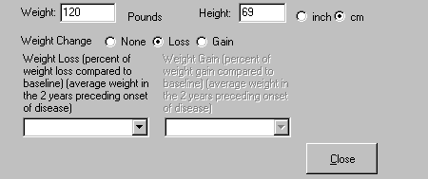

Figure 4.2.1b: Weight Change: Loss – Displayed on Report
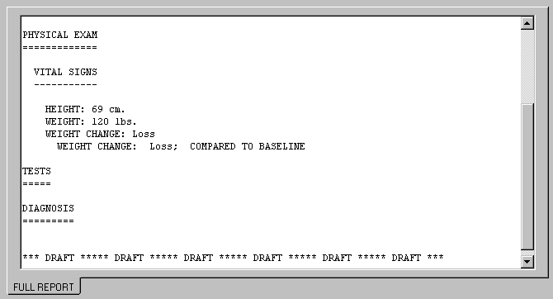

Weight Change: Gain with no % of weight change selected
Figure 4.2.2a: Weight Change: Gain – Entered on Template
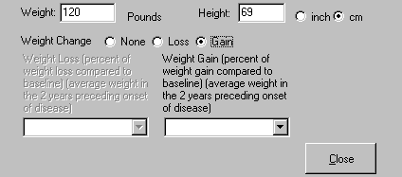

Figure 4.2.2b: Weight Change: Gain – Displayed on Report
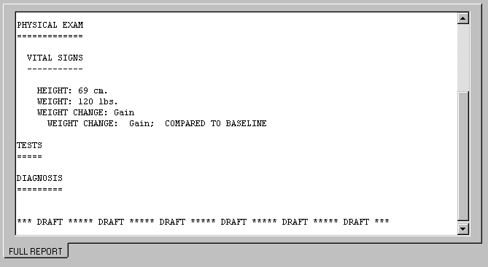

Weight Change: None

Figure 4.2.3a: Weight Change: None – Entered on Template
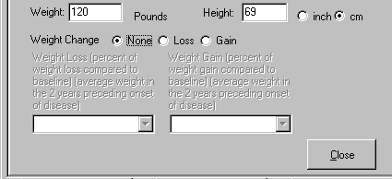

Figure 4.2.3b: Weight Change: None – Displayed on Report
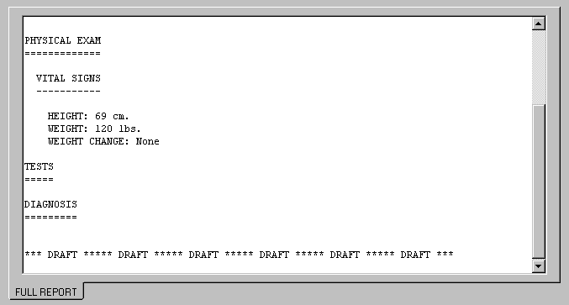

Software and Documentation Retrieval

VistA Patch DVBA*2.7*142

The VistA software is being distributed as a PackMan patch message through the National Patch Module (NPM). The KIDS build for this patch is DVBA*2.7*142.

User Documentation

The user documentation for this patch may be retrieved directly using FTP. The preferred method is to FTP the files from:

download.vista.med.va.gov

This transmits the files from the first available FTP server. Sites may also elect to retrieve software directly from a specific server as follows:

OI&T Field Office FTP Address Directory
Albany ftp.fo-albany.med.va.gov [anonymous.software]
Hines ftp.fo-hines.med.va.gov [anonymous.software]
Salt Lake City ftp.fo-slc.med.va.gov [anonymous.software]

The following files will be available:

File Name Format Description
DVBA_27_P142_RN.PDF BINARY Release Notes

The VistA Documentation Library (VDL) web site will also contain the 'DVBA*2.7*142 Release Notes'. This web site is usually updated within 1-3 days of the patch release date: http://www4.va.gov/vdl/application.asp?appid=133

